Testing result
Valid：(∀x. P(x))→(∃x. P(x))
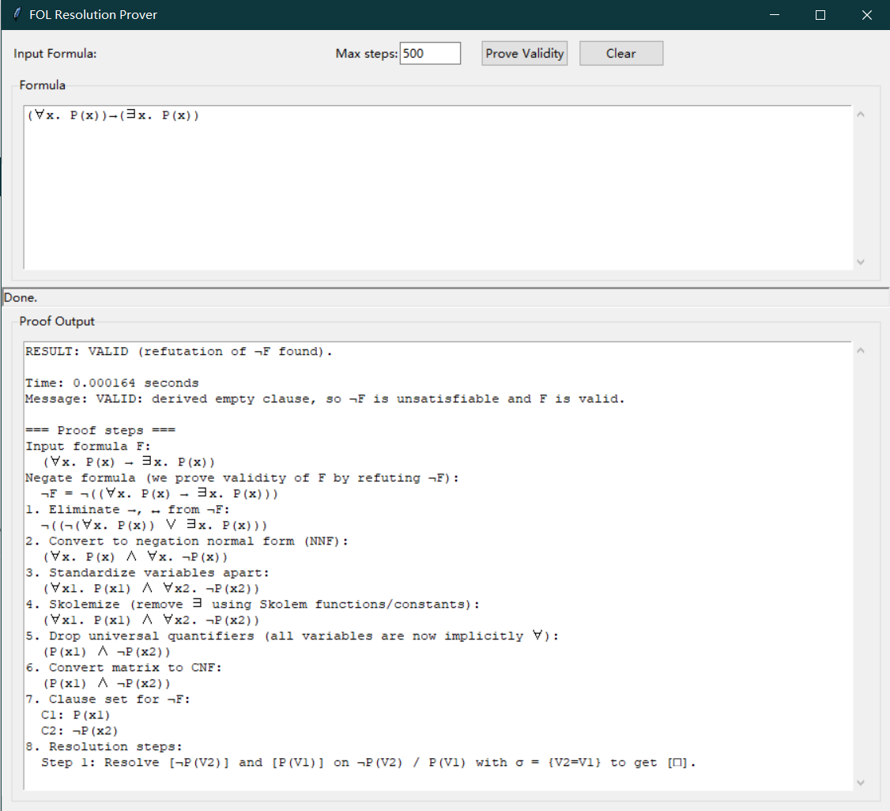
Not valid: (∃x. P(x))→(∀x. P(x))
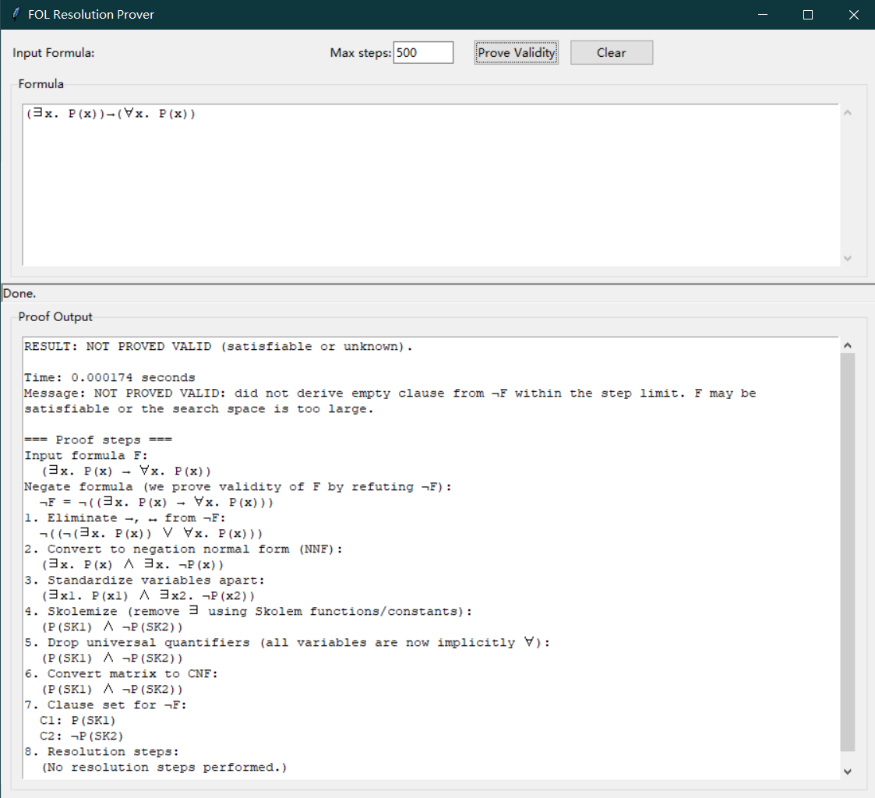
Other input way:
(forall x. P(x)) -> (exists x. P(x))
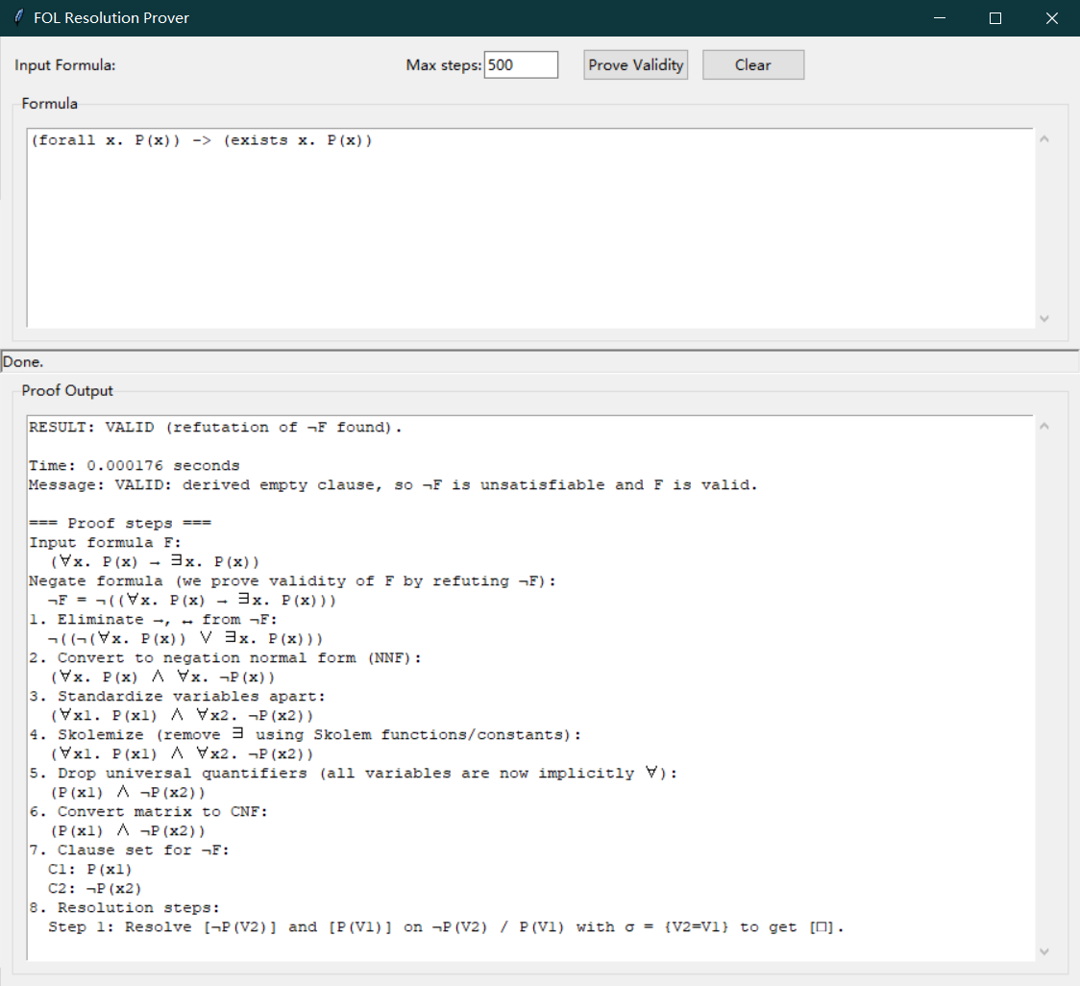
(exists x. P(x))-> (forall x. P(x))
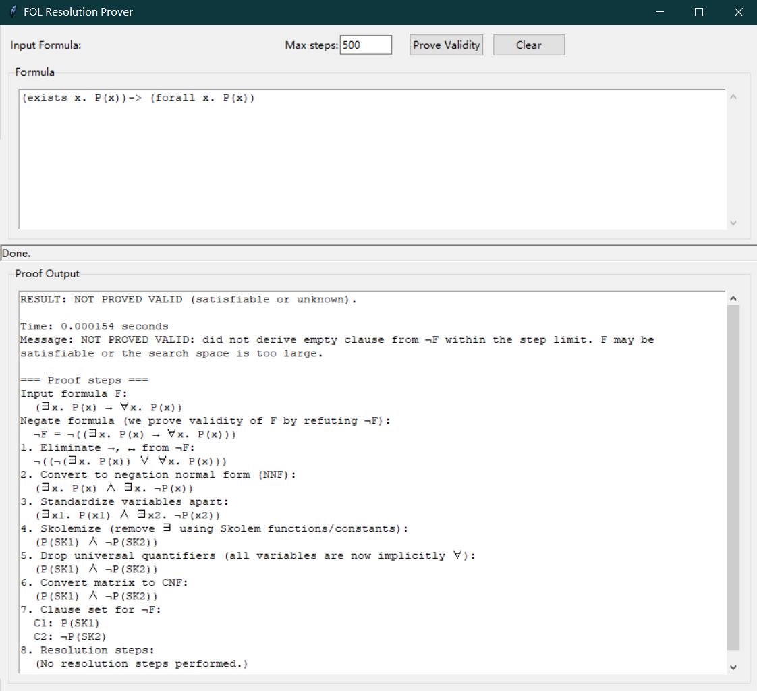
Increase clauses:
∀x. (p(x) ∨ q(x)) → ∃x. (p(x) ∨ q(x))
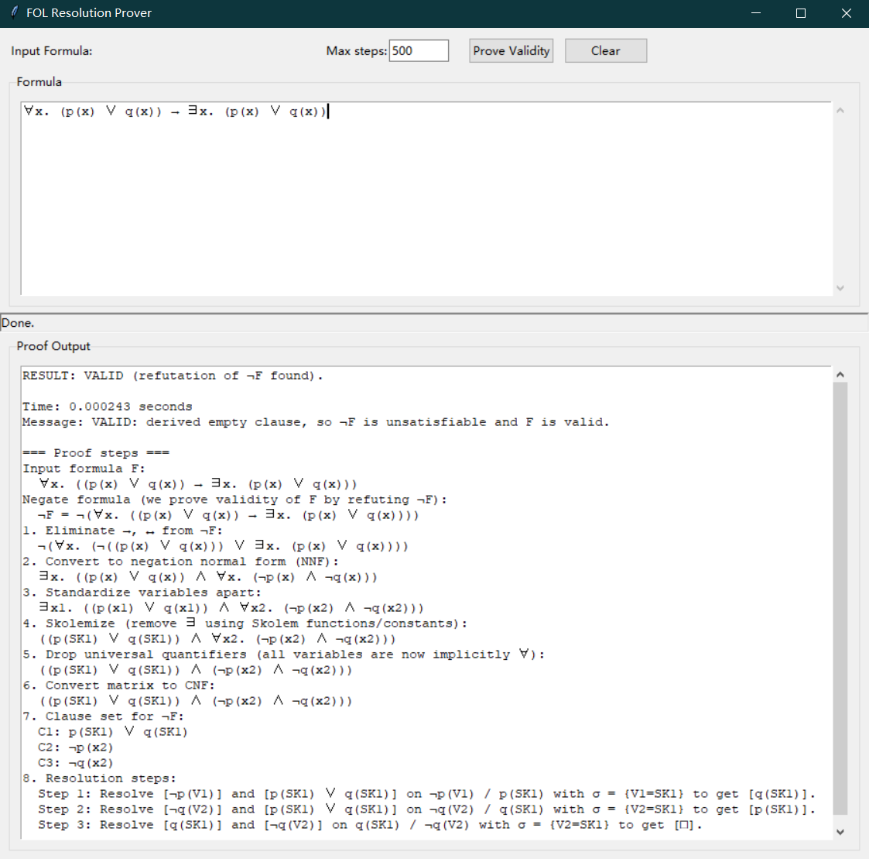
¬(∃y. ∀z. (p(z, y) ↔ ¬∃x. (p(z, x) ∧ p(x,z))))
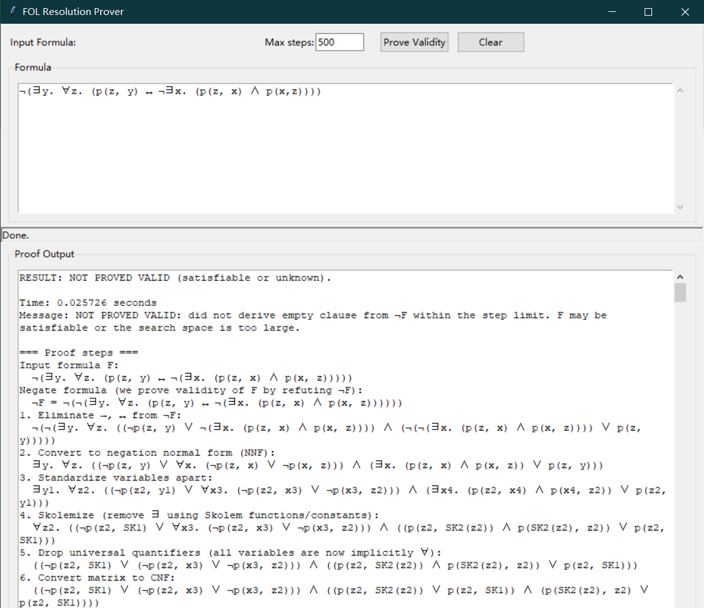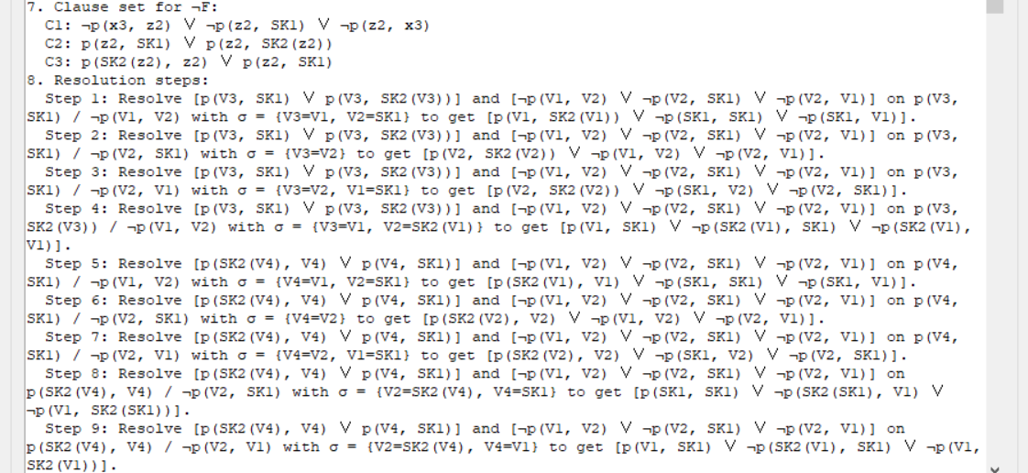
...
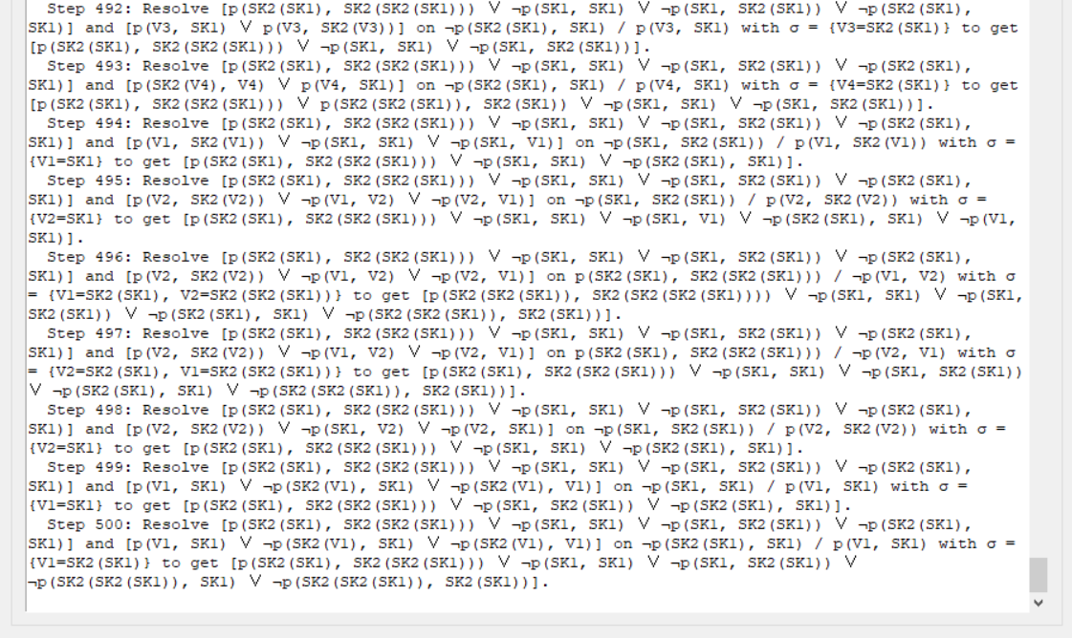
Wrong input:
∃xP(x)→∀xP(x)
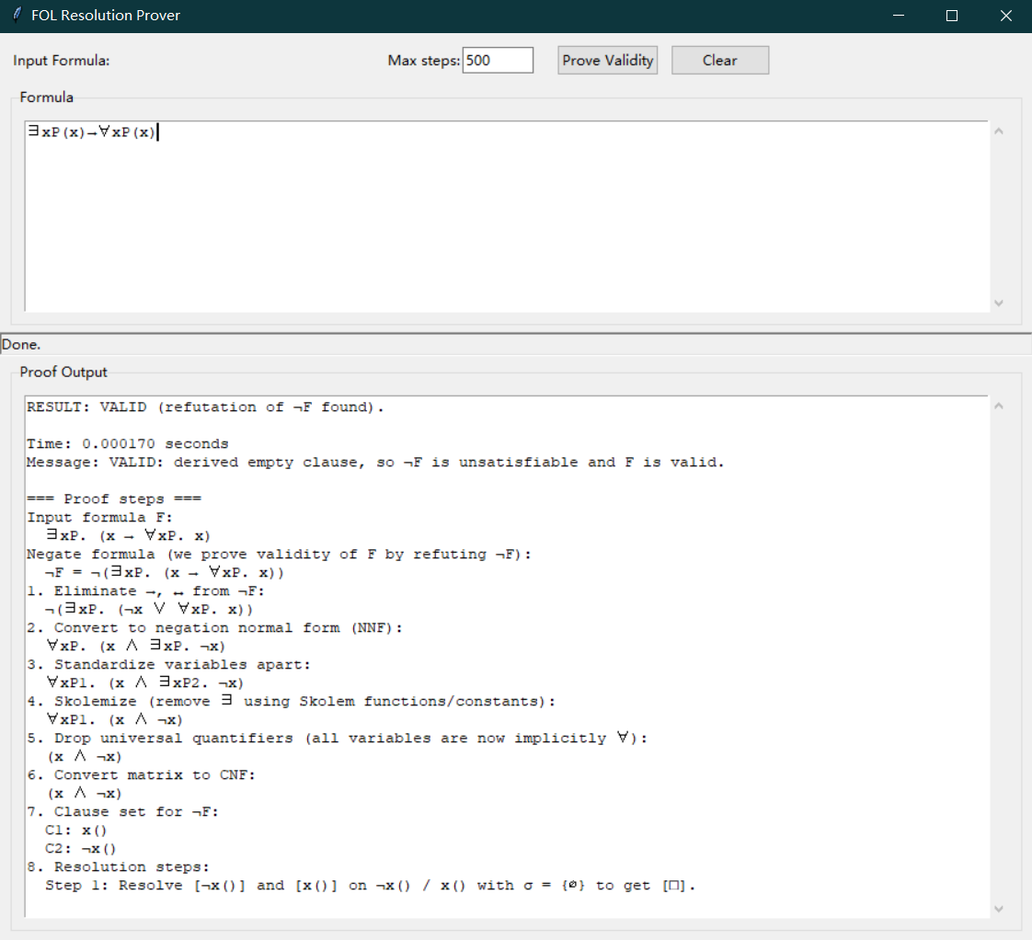
For all x in P(x) implies exists x in P(x)
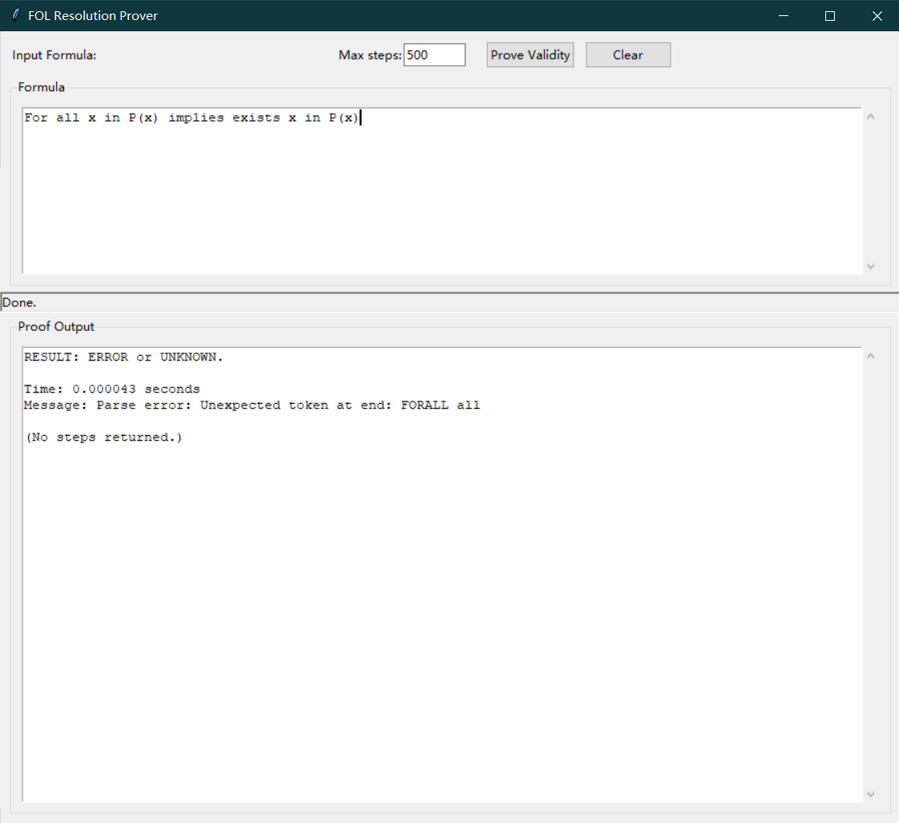
Empty input:
